Animesh Parab T2-t21 88

ASSIGNMENT-10

AIM:- To create a Lambda function using Python for adding data to Dynamo DB database.

LO MAPPED: LO1, LO5

THEORY:-
DYNAMO DB
Amazon DynamoDB is a fully managed NoSQL database service that provides fast and predictable performance with seamless scalability. DynamoDB lets you offload the administrative burdens of operating and scaling a distributed database so that you don't have to worry about hardware provisioning, setup and configuration, replication, software patching, or cluster scaling. DynamoDB also offers encryption at rest, which eliminates the operational burden and complexity involved in protecting sensitive data.
With DynamoDB, you can create database tables that can store and retrieve any amount of data and serve any level of request traffic. You can scale up or scale down your tables' throughput capacity without downtime or performance degradation. You can use the AWS Management Console to monitor resource utilization and performance metrics
DynamoDB provides on-demand backup capability. It allows you to create full backups of your tables for long-term retention and archival for regulatory compliance needs.
Steps :-
- Login to AWS account and search for DynamoDB in search bar
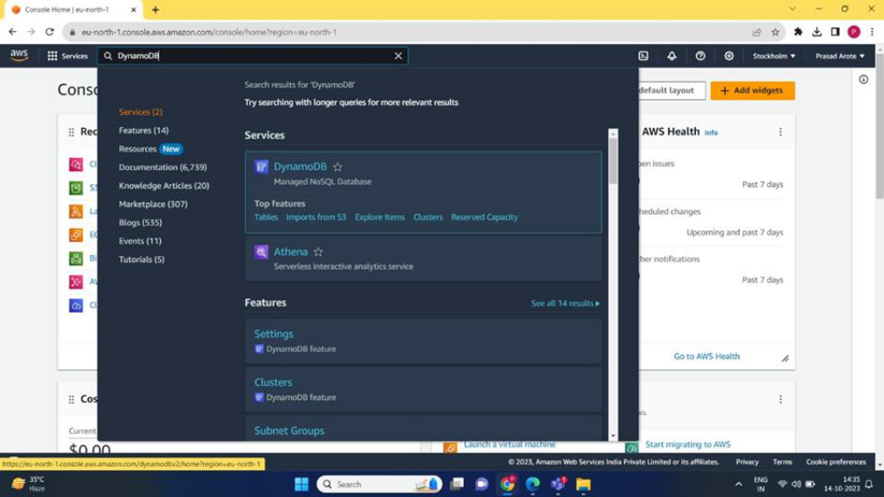

- Click on DynamoDB option shown above and then click on create table
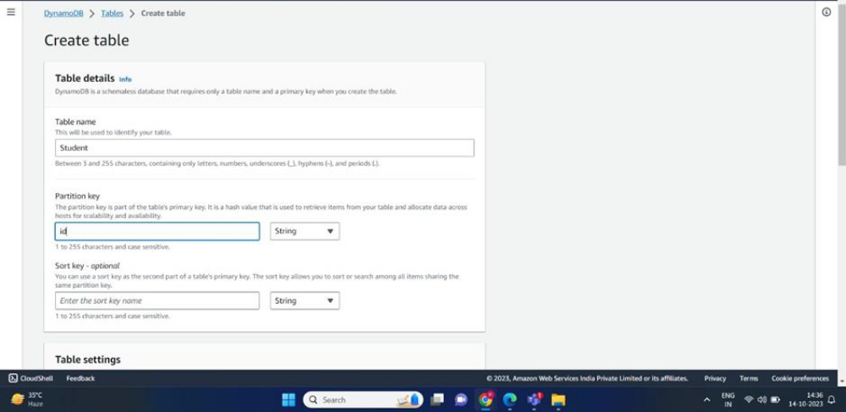

3)Then search IAM in the search box above and create a new role , give AmazonDynamoFullAccess permission to created user
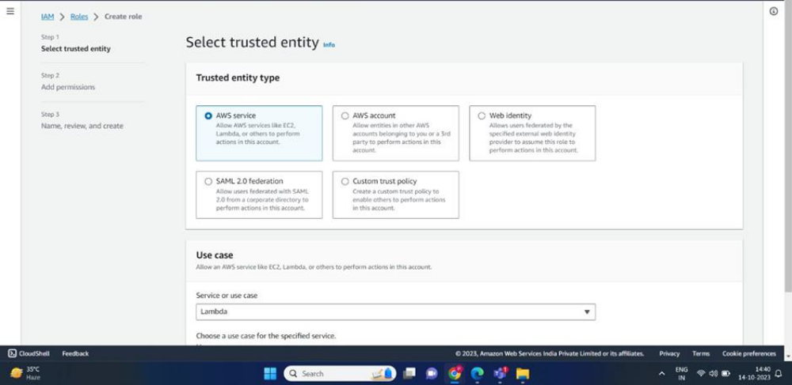
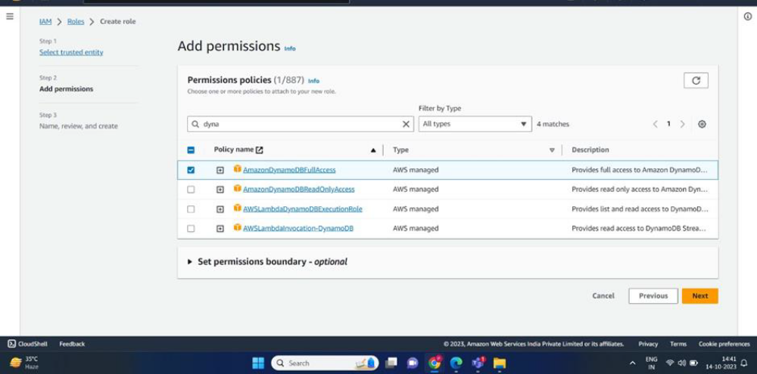
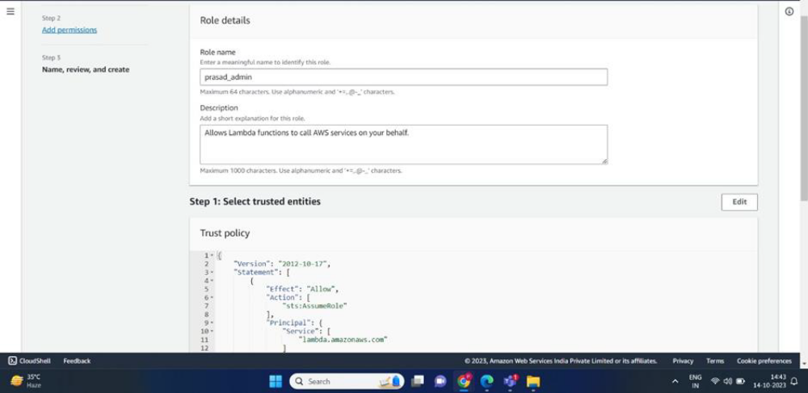
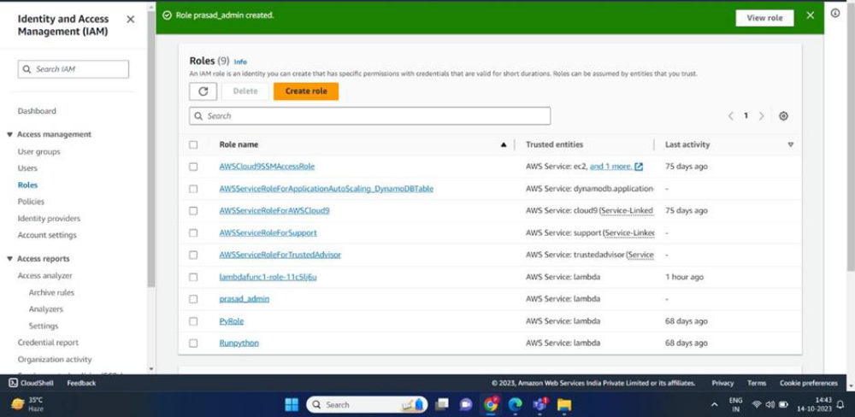
- Search Lambda in search box and click on it , then create a new lambda function
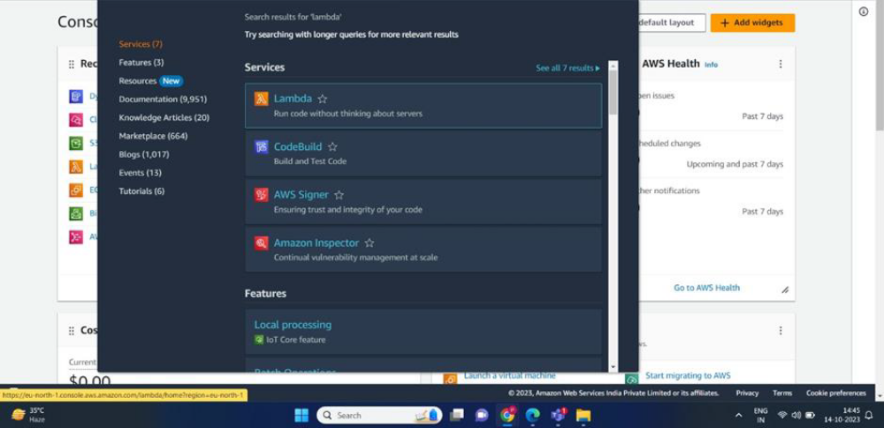
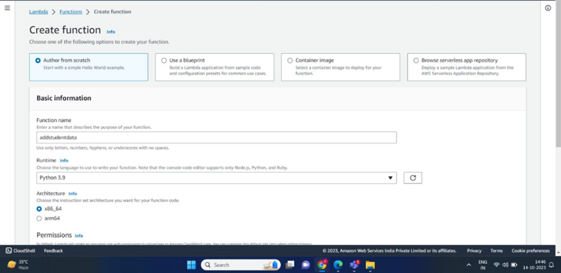
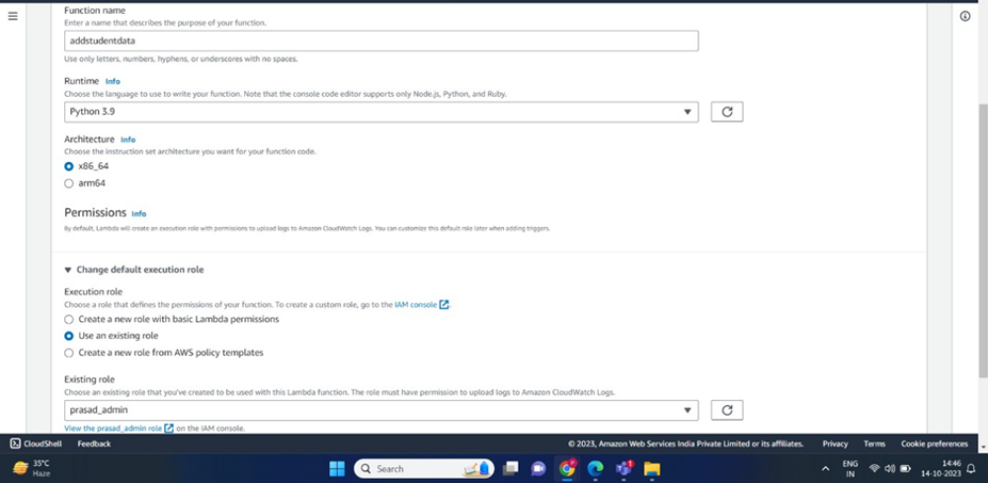
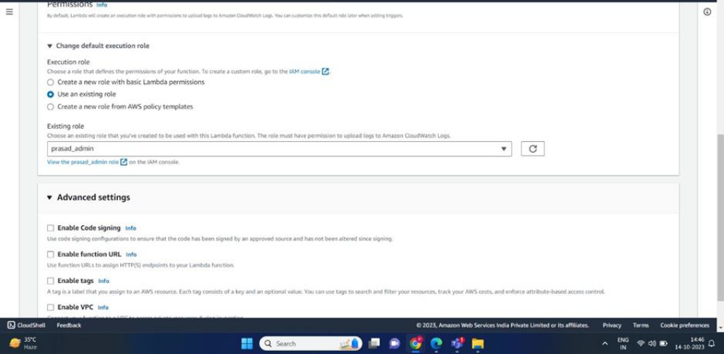
- Write the following code in code source
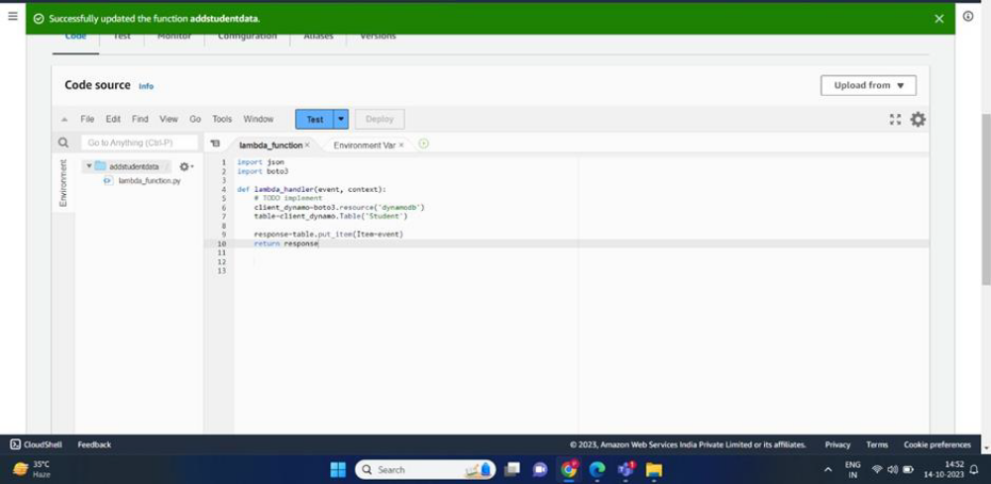

- Configure the test event and save
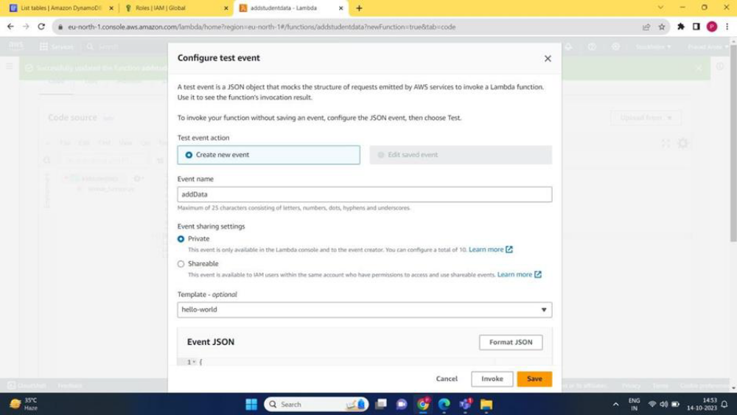

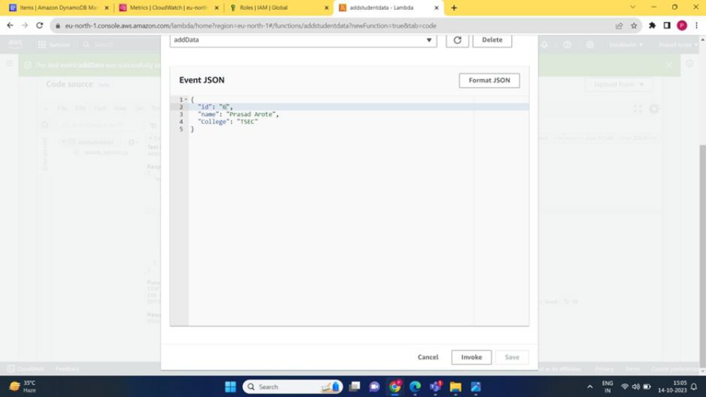

- Run the test and afterwards go to the DynamoDB>Explore items> Student where you can see the record inserted using lambda function.

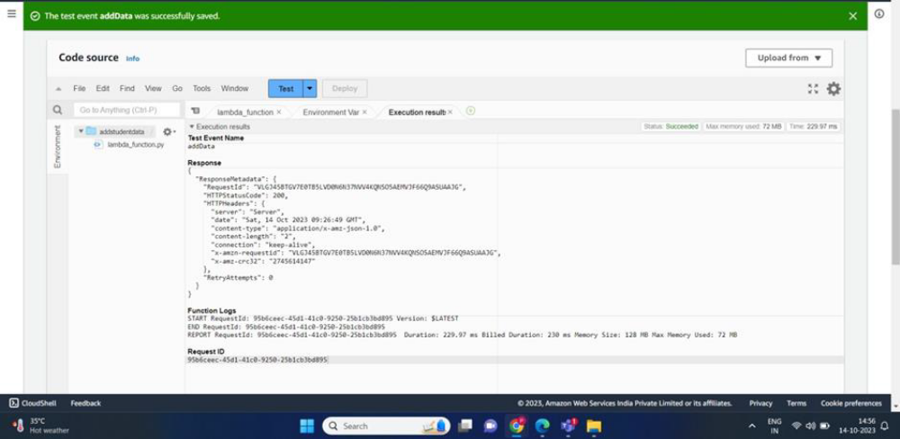

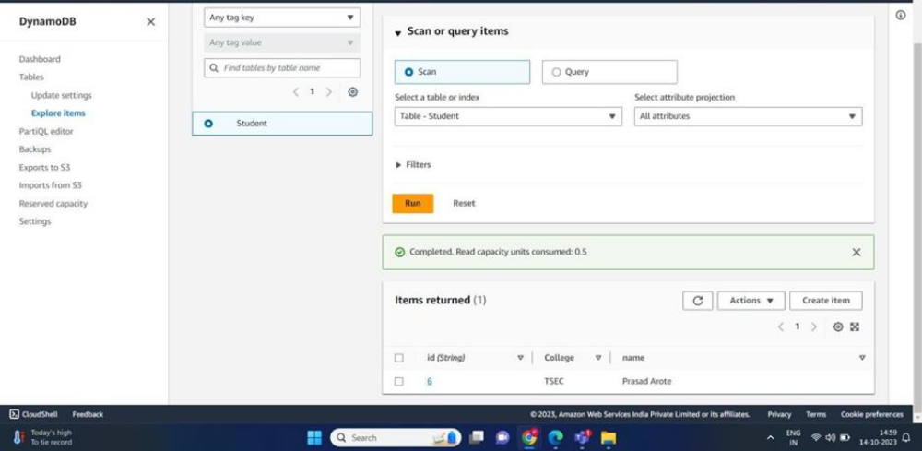

CONCLUSION:-
Learnt about Amazon DynamoDB database service and inserted data into DynamoDB database by creating a new user , granting him permissions and then using a lambda function

